1. Create a new project with AL: GO! Command by doing ctrl + shift + p
2. In Launch.json add your pc and server configurations and development port number

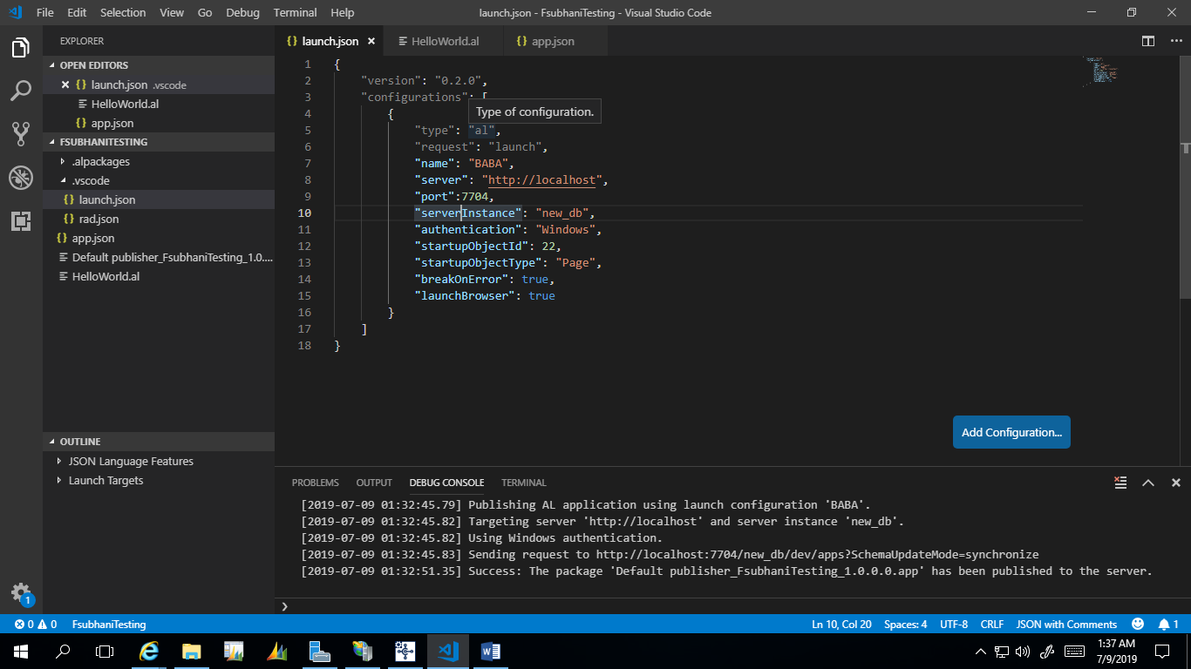

1. In App.json change runtime to 2.0 and platform + application to 13.00
2. Remove id ranges and context url
3. Add target internal

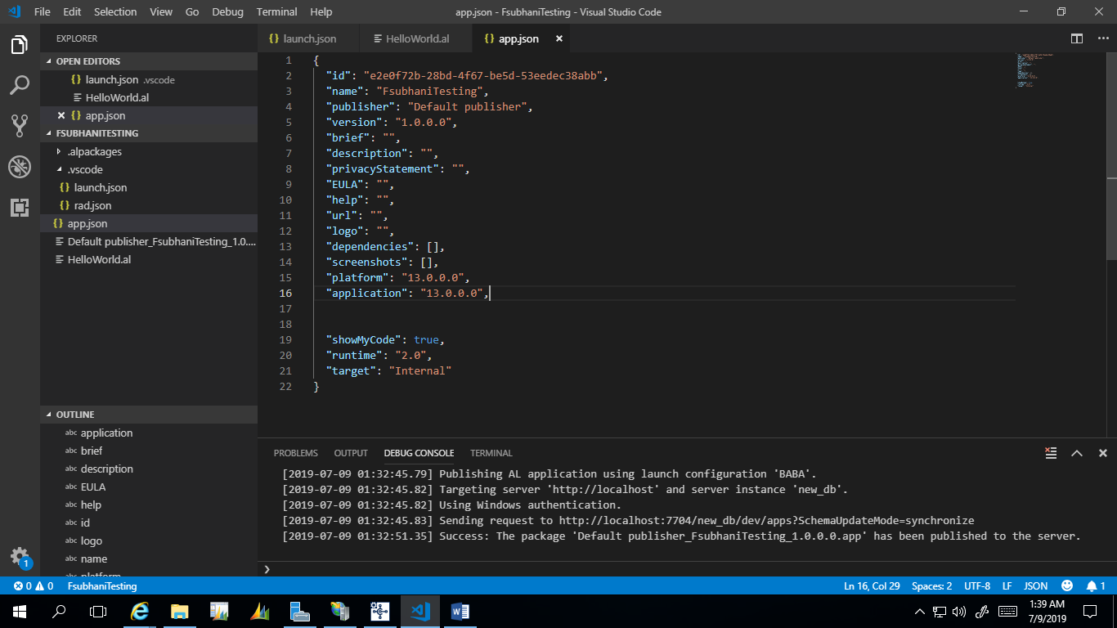

1. Download the symbols with ctrl + shift + p
2. Publish the project with shift + F5
3. There you go  
   